Weißt eh
On the German particle eh in the discourse marker weißt eh ‘you know’

? Course code:
Candidate number: 5355
? Word count: 4260
Date: 30.05.2026

Table of Contents
1 Introduction 1
2 Corpus study 1
3 Survey 2
3.1 Method 2
3.2 Results 2
3.3 Discussion 2
4 Conclusion 2
5 Data availability 3
6 Literature 4
Appendix 5

between 20 700 and 25 300 characters (no spaces))

CHECK ALL NUMBERS!!!

Introduction
A so far little investigated but colloquially frequently used word is the German particle eh. It can appear as the only particle in a sentence (1a) and in combination with other particles (1b).
(1a) Du kennst dich hier eh aus.
You know yourself here EH out
‘You know this place EH.’
(1b) Du kennst dich hier ja eh aus.
You know yourself here JA EH out
‘You know this place JA EH.’
Germany, Austria and Switzerland, have their own standard variety of German to which I will refer to as “Federal German”, “Austrian German” and “Swiss German”. Zobel (2017) is the first to differentiate between eh_{D} and eh_{A} showing that the particles meaning and therefore usage differs between Federal German and Austrian German. Both are stress bearing, but only EHD is always synonymous with sowieso ‘anyways’. EHA conveys an inner attitude. In declarative sentences, the owner of that attitude is the addressee whereas it is the speaker’s attitude that is communicated in interrogatives (Zobel, 2017, pp. 324-325).
The author describes the meaning of EHA regarding a proposition p as the following: “The speaker (cS) believes that the addressee’s (cA)/her belief worlds are compatible with both p and ¬p and that the addressee/she wants p to hold” (Zobel, 2017, p.325). In example (2), B claims that they manage to do something on their own (=p). As B includes EHA in their answer, B communicates that they believe that A is unable to rule out ¬p but wants to eliminate it. In other words, B states that they do not need help (=p) to accomplish something and by adding EHA to their utterance, B shows that they think A is unsure if they need help (¬p) but wants them to not need help (p).
(2) A: Do you need help?
B: Nein, ich schaffe das EHA allein.
No, I manage that EHA alone.
‘No, I can manage that EHA on my own.’
After conducting a corpus study, Zobel (2017) concludes that Federal German only has EHD, while Austrian German has eh both in the form of EHD and EHA. Even in Bavaria, the southern area of Germany at the border to Austria, the distinction between EHD and EHA remained true as EHA was not found.
A recent study by Vergeiner and Bülow (2025) looked at the different functions of eh comparing their acceptability and usage between Austria and Germany. By analysing spoken corpus data from Austria, the authors destinguish eleven unique ways of using eh which they investigated in a further online study. Participants from Bavaria, Northern Germany and Austria were asked whether they would use eh as in the provided example and had to rate its appropriateness.
Out of the eleven items, only one was used by the majority of all three groups (96 %, 89 %, 96%). It that example, eh can easily be exchanged with sowieso and thus is the EHD. The results from eight other examples, in which the used eh corresponds to the meaning of EHA described by Zobel (2017), show it exclusive use in Austria, thus confirming Zobel’s (2017) conclusion.
However, two items diverge – in combination with the word weißt ‘you know’, eh can be used as a discourse marker, to point to known or understandable issues. Here, 51% of the Bavarian participants reports to use eh in that way, while the 84% the participants from Northern Germany report to not use it.
(3) A: By the way, sorry for leaving so early yesterday
B: No worries
B: But what happened?
A: Weißt eh, anstrengende Woche
you.know EH, exhausting week
‘You know, exhausting week’
A: And I still have to do some uni-stuff today (Vergeiner & Bülow, 2025, p. 89)
Interestingly, when eh is combined with siehst ‘you see’, both groups report to not use it (51% and 82%). The second item that breaks the pattern is eh klar where eh is combined with klar ‘obvious’ and used as Back-Channel-Behaviour that signals the speaker’s agreement on the adressee’s evaluation (Vergeiner & Bülow, 2025).
Due to the temporal limitations of this thesis, I had to choose one of those irregular findings, which is the phrase weißt eh. The aim of the current thesis is to further explore the use and meaning of weißt eh by conducting a small corpus study as well as using an online questionnaire to collect native speakers’ intuition on its meaning and verify how people use it. Additionally, I aim to find out if the eh in weißt eh is the EHD or EHA.
As the current literature does not include Swiss German, I am including that variety in addition to Austrian and Federal German in the corpus study described in the following part.

should I include some more background information on what a discourse marker is? How they are classified?

Corpus study
The corpus study is a means to investigate in which standard varieties of the German language the combination weißt eh is found and whether it really is a pragmatized phrase as Vergeiner and Bülow (2025) state. Moreover, I am looking into the different conjugations of the verb wissen ‘to know’ and dialectic versions of it. The data used in the corpus study was derived from the Deutscher Referenzkorpus – DeReKo on ‎29th March ‎2026 and 19th April 2026 and is available through the osf repository (see 5 Data availability).
Figure 1 illustrates the distribution of word forms across the different countries. In total, the corpus search gave 283 results, with five different word forms of the verb wissen ‘to know’. Three of them are conjugated in 2nd person singular, like the standardized (du) weißt (n = 228). In addition to that, two dialectic version waßt (n = 26) and woaßt (n = 13) were found too. Word forms that differed only in the spelling of the ß/ss are treated as the same form. Moreover, wisst’s (n = 5) conjugated in the 2nd person plural and wissen’s (n = 11) in 1st or 3rd person plural occurred.
Looking at the distribution across the countries, 78% of the entries were from Austrian newspapers (n = 220), 21% from German sources (n = 60) and only 1% were Swiss (n = 3).
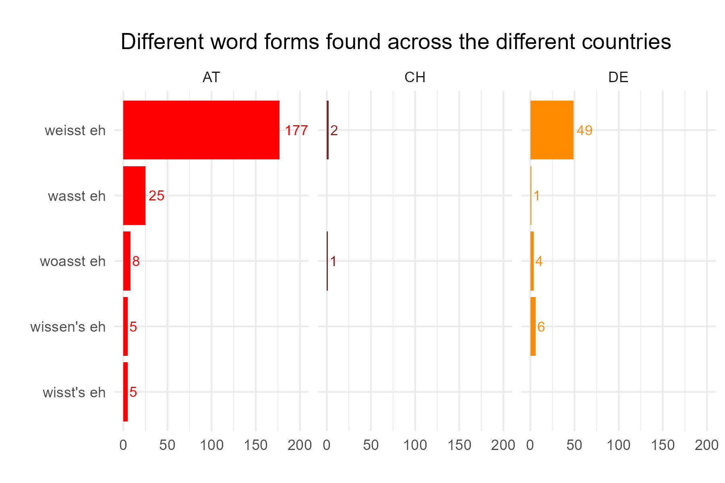
Figure 1 – Distribution of the different word forms across the countries Austria (AT), Switzerland (CH) and Germany (DE), illtustrating the predominance of ‘weißt eh’ followed by the other 2nd person singular forms ‘waßt eh’ and ‘woaßt eh’.
Regarding the position and function of WEISST EH, it is either standing completely on its own (see example (4)) or embedded in another sentence. The latter can be as part of a declarative sentence, where the verb wissen is the main verb of the main clause (5a), or as a discourse marker, marked by a comma in the beginning and/or end of the phrase depending on its position within the sentence (5b).
(4) example freistehend als „“
(5a) example embedded, dass/wie…
(5b) example discourse marker
In only 8 examples, WEISST EH was standing free. In the other 97% of the data, it was embedded. Out of the 283 examples, 61% (n=172) of the time, it functioned as a discourse marker while in 31% (n=111) of the examples, it was embedded in the main clause of the sentence. Figure 2 illustrates how the different positions and functions combined with each other.
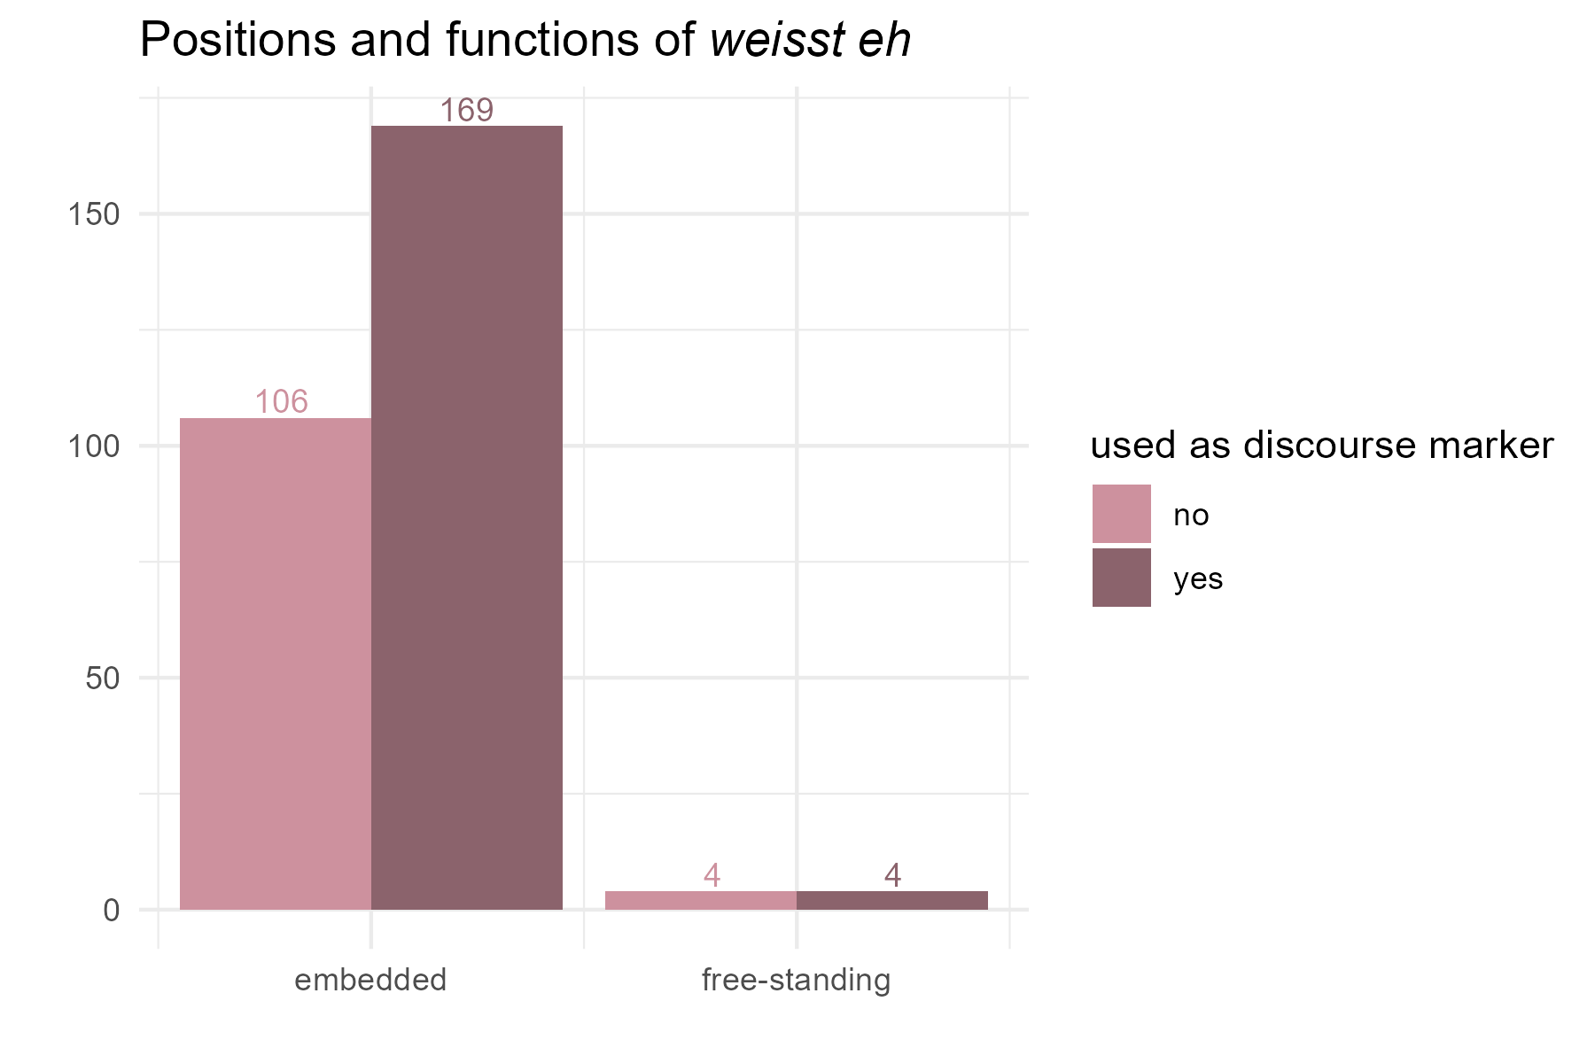
Figure 2 – Distribution of position and function of the corpus data (n= 283).
The biggest difference between functioning as a discourse marker or being part of the main clause seems to be that the former can be removed without turning the same utterance ungrammatical. For the free-standing examples, it was more difficult to use that distinction, as WEISST EH was a complete utterance on its own. In three of the four examples I classified as free-standing and discourse marker, however, the utterance continued. The only reason they were classified as free-standing in the first place was due to the orthographic choices of the journalist, who marked the end of the sentence by using an exclamation mark right after the WEISST EH. In the other example, WEISST EH was given in direct speech and as it was the only two words of that utterance, I classified them as free-standing too. From the context, it is likely that the speaker continued speaking after those words, even though it is not reported. The other four examples classified as free-standing without being a discourse marker, were either cases where several phrase like WEISST EH were named and discussed or a comment on this phrase was given.
I am not only interested in how often WEISST EH is used a discourse marker but especially in whether this function is found in the different varieties of German. With their example of WEISST EH Vergeiner and Bülow (2025) only investigated if participants would use it as a discourse marker, not if they would use this word combination in general. Figure 3 shows that the countries differ strongly in how they use WEISST EH. In few instances found in Swiss German were never as a discourse marker. Austrian German to Federal German show opposite patterns – around 70% of the time Austrians use the phrase as discourse marker while Germans only do that 27% of the time. Instead, it seems more common (73%) to use WEISST EH in the main clause of the utterance.
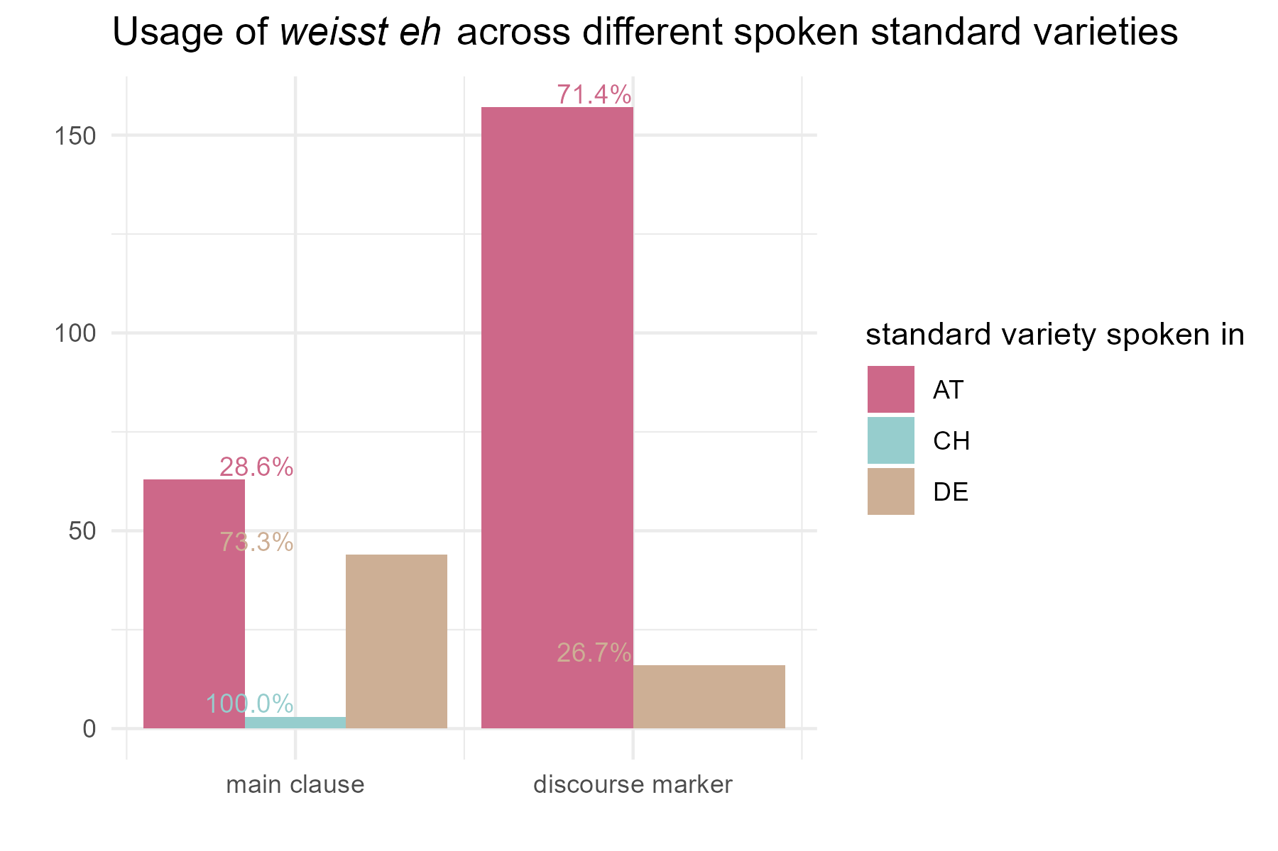
Figure 3 – Usage of ‘weißt eh’ across the different countries and their spoken standard variety
As noted above, Vergeiner and Bülow (2025) describe WEISST EH as pragmatized phrase. To test that my corpus search included the modal particles ja, denn and leicht. If another particle, can be inserted in weißt _ eh, it is not a closed phrase yet. Moreover, knowing which particles are found in combination with WEISST EH, would provide information on the phrase itself. Ja is only found in declarative sentences, whilst denn and leicht are restricted to interrogatives (Thurmair, 1993). However, there were no results in the corpus for WEISST denn EH and WEISST leicht EH. There were 19 results, one for waßt ja eh and 18 for weißt ja eh, distributed across all three countries, but in none of the 19 example the phrase was used as a discourse marker.
Even though the corpus search did not elicit any finding, that does not necessarily mean that it is completely unnatural or ungrammatical to use either of them. My native speaker intuition tells me that both (6a) and (6b) are very bad, while (6c) sounds quite fine.
(6) examples with denn, Leicht and ja.
At next, I looked at the distribution of pronouns. In the example used by Vergeiner and Bülow (2025), the phrase WEISST EH did not include a pronoun. The corpus research showed that it is possible to use a pronoun even when WEISST EH is used as discourse marker, even though it is very rare (6%, n = 10 out of 171). Used as a part of the main clause, there was almost no difference. Here, WEISST EH appeared 50% (n = 56 out of 112) without a pronoun and 50% with.
While most pronouns used were personal pronouns, demonstrative pronouns and proper nouns preceded the phrase in five examples, none of them are discourse markers.
10% of all examples from the corpus search had a conjunction preceding WEISST EH. 18 examples (10.5%) where WEISST EH functions as discourse marker include a conjunction. Aber ‘but’ (n = 13) is the most frequently used. The others found are und ‘and’ (n = 3) and weil ‘because’ (n = 2). Interestingly, those three conjunctions differ in their placement with regards to the phrase WEISST EH. As mentioned above, when the discourse marker appears within the sentence, it is marked with a comma preceding and following WEISST EH. Only aber ‘but’ appeared (n = 5) within the commas of the discourse marker (7a). In that position, both aber ‘but’ and weil ‘because’ can be to the left of the comma, outside of the discourse marker, but und ‘and’ did not appear in this position (n = 11) (7b). If the discourse marker is sentence initial, all three conjunctions can precede it. In sentence initial position, there is only a comma following the discourse marker. Only two out of the 18 examples with a conjunction had the conjunction placed outside of the discourse marker as illustrated in (7c).
(7a) …, aber/ ?und/ ?weil WEISST EH, …
…, but/ ?and/ ?because KNOW EH, …
(7b) Aber/ ?Und/ Weil ,WEISST EH, …
But/ ?And/ Because ,KNOW EH, …
(7c) Aber/ Und/ Weil WEISST EH, …
But/ And/ Because KNOW EH, …
Are those examples enough or do they have to be full sentences?
Lastly, I investigated the different placements of the embedded discourse marker. Most examples have the discourse marker in sentence initial position (n = 106, 63%), followed by sentence medial position (n = 49, 29%) and sentence final position (n = 12, 7%). When the discourse marker is placed in the middle of a sentence, its position can either be clause initial, clause final or clause medial. Most of the examples (n = 31) can be read as either clause initial or final, while others only make sense in one way. Both conjunctions and pronouns were only used sentence initially but not in sentence final examples. Therefore, when the discourse marker appeared in the middle of a sentence and included a conjunction and/or a pronoun, it is more natural to read them as clause initial (n = 12). In seven of the sentence medial cases, the discourse marker was also placed clause medial.

By looking at the data, I noticed some patterns in how the sentences continued or started depending on the placement of the discourse marker, summarized by the table below. Some examples are answers to a question asked by another person. When the answer included a word such as ja, na, na geh, naja or nein, it always preceded the discourse marker (see table 1, 1).
Do I need to explain all of that? I am afraid I will end up writing way too much. Or is it enough to give one example with interlinear glosses per line?
Would the whole table than count into the word count?
table 1
1 | Na geh, Na, Naja, Ja, Nein | WEISST EH | (…)
2 |  | WEISST EH | bei ‘at’ | …
3 |  | WEISST EH | def. article | noun sing.
4 |  | WEISST EH | noun sing. | und so.
5 |  | WEISST EH | noun sing. and noun sing. | …
6 |  | WEISST EH | wegen ‘because of’ | …
7 |  | WEISST EH | name | …
8 | name | WEISST EH | …
9 |  | WEISST EH | explanation
10 | explanation | WEISST EH
11 |  | WEISST EH | ich bin | …
12 | ich bin … | WEISST EH
13 | das ist | WEISST EH | …
14 | topic | WEISST EH | continuation
only sentence and clause initial
only clause initial
sentence medial
clause medial
clause initial
clause final
Or shall I just write about what I am using for constructing the examples?
Notes for describing the table if I do so:
WEISST EH in front of determiner phrase with a noun
often def article + noun
only clause initial, most frequent
or DP (noun/propper name) und so.
here no determiner/article 3x
clause initial 4x, 1x nein, WE, … und so.
WEISST EH, x and y …
only clause initial 3x
WEISST EH, bei
only clause initial (also all sentence initial)
WEISST EH, wegen ‘because of‘
only clause initial
once:
Na geh WEISST EH! Wegen ...
WEISST EH, indef noun and indef noun …
be followed by a complete sentence, often an explanation
sometime, not fully grammatical on its own by also an explanation.
_ich bin_
WEISST EH, name, …
way more common!
but twice: name, WEISST EH, …
das ist, WEISST EH, …
ich bin …, WEISST EH.
when sentence middle, clause initial, the following sentence/clause is a continuation on the other one or explanation
claim, weisst eh, elaboration
example with shoes

middle, that person, weisst eh, from the news
two ways, either it is strictly within the same clause so that by removing the discourse marker, one would just continue within the same clause, often an adjunct of a noun phrase.
or topic introduction, weisst eh, new clause continuing that topic
Many examples of WEISST EH in sentence or clause initial position
more common to have name WEISST EH preceding a name
how do I cite examples from the corpus search correctly?
Mention that there are a few questions? Where? DO I have enough space for that? Or is that unimportant?
To further explore the rules and meaning of the discourse marker WEISST EH, I conducted an online survey which the next part of my thesis is describing.
Where can the discourse marker be placed?
In the exploratory study I will therefore include examples and questions that include other particles. However, as my goal is to find out more about weißt eh used as discourse marker, all examples are restricted to that function only. In the next part, I am elaborating on the method and decisions behind the questionnaire before the results are reported and discussed.

Survey

Method
The online survey was conducted with a questionnaire on nettskjema.no. All questions and answer options were given in German. Participants were recruited through Facebook, Instagram and my social network, where they received an invitational message with a link to the introduction page. A translation of the instructions given can be found in the appendix. When proceeding by clicking a button, participants were redirected to another questionnaire.
Because I operated with minimal triplets, there were three versions of the second questionnaire to which participants were randomly assigned to. The second questionnaire always consisted of three parts. The first part, which was identical in all three versions, aimed to collect data regarding there background to assess which standard variety of German they are speaking. Participants were asked in which country they spent most of their childhood and in which country their current center of their life is. Both were multiple-choice questions with the answer options Germany, Austria, Switzerland and different. Both questions had follow-up questions asking about the state for participants who answered with Germany and/or Austria and providing a list of all the states of the respective country as a multiple-choice question. Moreover, participants were asked if they considered German to be on of their first languages and could answer with either yes or no.
Additionally, I asked them which of the following expressions they use in their oral language use. They were instructed to think of their dialect and informed that they could choose several options – which were “woaßt eh”, “waßt eh”, “weißt eh”, all three and none. Below, they were informed that all oft eh following examples are written in colloquial language because eh is generally only used orally. Participants were instructed to read the examples out aloud in their own dialect and exchange “weißt eh” with “woaßt eh” or “waßt eh” if they are more natural for them, and to trust their gut feeling when answering the now following questions.
The questionnaire had 9 examples in total, each one with its unique context given as a short everyday dialog. Example 1 to 3 constituted the second part of the questionnaire investigating if WEISST EH is a pragmatized expression. Participants were asked how natural they found the use of the discourse marker in the following context, by rating it on a scale from 1 (completely unnatural) to 5 (completely natural). Additionally, they were asked if they would use the discourse marker in the given context in that way and had to choose between yes, no and unsure. The context of these examples consisted of two sentences by the same speaker. The first one introduced a topic, the second one elaborated on it. The discourse marker was always placed in sentence initial position of the second sentence. The discourse markers used were weißt eh, weißt ja eh and weißt denn eh. The three questionnaire versions were constructed in a way that ensured that all participants saw each context and each discourse marker only once but in different combinations. Moreover, the order of the contexts differed.
In the third part, example 4 to 9, only used the discourse marker weißt eh. The minimal triplets were achieved by placing weißt eh in different positions within the same context. Here, the order of the context per example stayed the same in the three versions. In addition to the same questions as for example 1,2 and 3, two more questions were asked except for when the participant rated the naturalness of weißt eh as completely unnatural. With those questions I aimed to understand the meaning of WEISST EH in different contexts and positions and how it can be paraphrased. I asked them, what weißt eh meant for them in the given context, giving them five answer options (see table 2) This question was a multiple-choice question. The last question looked at eh as a part of the expression weißt eh. Participants were asked the following question. Assuming that you cannot use the word “eh”: With which of the following formulations could you in this context best state the same as with “weißt eh”? They had to choose one option that included another modal particle out of du weißt ja, du weißt doch, du weißt schon, du weißt sowieso and (none of these fomulations fits for me).
on examples !!!
table 2
about oneself  example 4, 6, 8 & 9 | about another person  example 5 & 7
du weißt eh, warum  ‘you know EH, why’ | du weißt eh, wer das ist  ‘you know EH, who that is’
du weißt eh, was los ist  ‘you know EH, what is going on’ | du weißt eh, wen ich mein’  ‘you know EH, who I mean’
du kennst mich eh  ‘you know me EH’ | du kennst sie eh  ‘you know her EH’
das weißt du eh
‘you know that EH’
(keine dieser Formulierungen passt für mich)
‘(none of the formulations fits for me)’

on participants
exclusion criteria
The second part consisted of example 1 to 3 where I investigated if WEISST EH is a pragmatized expression, asking them how natural they found the use of the discourse marker in the following context, by rating it on a scale from 1 (completely unnatural) to 5 (completely natural). The context of these examples consisted of two sentences by the same speaker. The first one introduced a topic, the second one elaborated on it. The discourse marker was always placed in sentence initial position of the second sentence. The discourse markers used were weißt eh, weißt ja eh and weißt denn eh. The three questionnaire versions were constructed in a way that ensured that all participants saw each context and each discourse marker only once but in different combinations. Moreover, the order of the contexts differed. so that the different groups saw the different discourse markers in different orders. For each each example the were
differed in which example included which discoursemarker
the discourse marker was placed sentence initial and preceded by another sentence by the same speaker that provided the topic. After the discourse marker, the
all examples without pronouns as it is more common
versatile examples where disc marker can be placed indifferent locations, I did not use pronouns or conjunctions. Moreover, all examples showed the word form weißt eh as this is the most common one.
Actually, no middle middle examples used?! – wrong the one med schauspieler is middle middle? NO? Isnt it actually

I also used punctuation marks to reinforce certain positions and keep it open to the reader to interpret a sentence middle position as clause initial or clause final, by using commas in front and after the discourse marker and no capital letters.

around 1 page
!!! how I categorized the examples!!!
position of phrase within clause and sentence! some percentages!!!
And how they end/continue!
how did I do everything?
EXCLUSION CRITERIA!!!
born/grown up somewhere else?
not german as mother tongue
if someone say one version is very natural but votes completely or unnatural for all the weisst eh ellers
nevne det med min scale

Results
around 3 pages
analyzing results

Discussion
around 2 pages
mention:
weisst’e in northern Germany
some people might have misunderstood the task?
scale I used is very uncommon thinking of the grading system used in both Austria and Germany where 1 is best and 5 is worst. This
I actually don’t have any middle middle examples… but thought I used them/one/two?

Conclusion
around 1 page

Data availability
All materials needed to re-run the experiment as well as the data collected and analysed can be accessed in the online repository through the following link: https://osf.io/urvpx/?view_only=6b5c1ff64dc440e187cd59496e995ec5
- where to find my exel table of corpora data
- find copy of my questionnaire as a png or just some documentation of how the questions were formulated
- examples
- answer options
- raw data of my analysis
- if I have any form of code for descriptive statistics
- and all tables used

Literature
Thurmair, M. (1993). Äußerungsform oder Äußerungsfunktion? Zu den Bedingungen für das Auftreten von Modalpartikeln. Deutsche Sprache, 21(1), 22–43.
Vergeiner, P. C., & Bülow, L. (2025). Zur funktionalen Variation von eh in Österreich und darüber hinaus. In S. Stumpf, M.-L. Merten, S. Kabatnik, & S. Zollner (Eds.), Variationspragmatik: Regionale Vielfalt und situative Unterschiede im Sprachgebrauch (Studien zur Pragmatik, Bd. 8, pp. 53–89). Narr.
Zobel, S. (2017). “Eh ist eh anders” – eh and sowieso in Federal German and Austrian German. In C. Mayr & E. Williams (Eds.), Festschrift für Martin Prinzhorn (Wiener Linguistische Gazette, No. 82, pp. 323–330). Universität Wien.

Notes on how to cite correctly:
Paraphrase: (Zobel, 2017)
Quote: (Zobel, 2017, p. 325)
Multiple pages: (Zobel, 2017, pp. 325–327)

Appendix
include the questionnaire examples 1-9 for all three conditions or just one?
Translation of introduction page - instructions
example 1
A: Ich freu’ mich so aufs Wochenende! Weißt eh, ich fahr’ in die Berge, zum Schifahren!
A: Bald hab’ ich’s geschafft! Weißt ja eh, in einer Woche hab’ ich die letzte Prüfung und dann wart’ ich nur noch auf das Ergebnis.
A: Am liebsten wär’ ich den ganzen Tag nur am See. Weißt denn eh, ich brauch’ eine Abkühlung bei der Hitze.
example 2
A: Am liebsten wär’ ich den ganzen Tag nur am See. Weißt ja eh, ich brauch’ eine Abkühlung bei der Hitze.
A: Ich freu’ mich so aufs Wochenende! Weißt denn eh, ich fahr’ in die Berge, zum Schifahren!
A: Bald hab’ ich’s geschafft! Weißt eh, in einer Woche hab’ ich die letzte Prüfung und dann wart’ ich nur noch auf das Ergebnis.
example 3
A: Bald hab’ ich’s geschafft! Weißt denn eh, in einer Woche hab’ ich die letzte Prüfung und dann wart’ ich nur noch auf das Ergebnis.
A: Am liebsten wär’ ich den ganzen Tag nur am See. Weißt eh, ich brauch’ eine Abkühlung bei der Hitze.
A: Ich freu’ mich so aufs Wochenende! Weißt ja eh, ich fahr’ in die Berge, zum Schifahren!
example 4
A: Warum hast du dir denn für den Sommer keinen Urlaub genommen?
B: Weißt eh, wegen der großen Reise im Herbst! Da kann ich mir davor nicht auch noch freinehmen.
A: Warum hast du dir denn für den Sommer keinen Urlaub genommen?
B: Wegen der großen Reise im Herbst, weißt eh! Da kann ich mir davor nicht auch noch freinehmen.
A: Warum hast du dir denn für den Sommer keinen Urlaub genommen?
B: Wegen der großen Reise im Herbst! Da kann ich mir davor nicht auch noch freinehmen, weißt eh!
example 5
A: Schau, da drüben! Das ist doch die Schauspielerin, weißt eh, die aus dem neuen Film!
A: Schau, da drüben! Das ist doch die Schauspielerin, die aus dem neuen Film, weißt eh!
A: Schau, da drüben! Weißt eh, das ist doch die Schauspielerin, die aus dem neuen Film!
example 6
A: Ich hab’ mir schon wieder neue Schuhe gekauft. Ich kann einfach nicht widerstehen weißt eh!
A: Weißt eh, ich hab’ mir schon wieder neue Schuhe gekauft. Ich kann einfach nicht widerstehen.
A: Ich hab’ mir schon wieder neue Schuhe gekauft. Weißt eh, ich kann einfach nicht widerstehen.
example 7
A: Wer ist denn das?
B: Weißt eh, die Julia, die Tochter vom Nachbarn, mit der wir als Kinder immer zusammen gespielt haben!
A: Wer ist denn das?
B: Die Julia, weißt eh, die Tochter vom Nachbarn, mit der wir als Kinder immer zusammen gespielt haben!
A: Wer ist denn das?
B: Die Julia, die Tochter vom Nachbarn, mit der wir als Kinder immer zusammen gespielt haben, weißt eh!
example 8
A: Ich geh’ gleich einkaufen für das Picknick morgen. Weißt eh, Obst und so.
A: Ich geh’ gleich einkaufen für das Picknick morgen. Obst und so, weißt eh!
A: Weißt eh, ich geh’ gleich einkaufen für das Picknick morgen. Obst und so.
example 9
A: Was ist denn los? Du schaust ja gar nicht gut aus!
B: Die Pollenallergie! Dieses Jahr ist es wieder besonders heftig, weißt eh!
A: Was ist denn los? Du schaust ja gar nicht gut aus!
B: Weißt eh, die Pollenallergie! Dieses Jahr ist es wieder besonders heftig.
A: Was ist denn los? Du schaust ja gar nicht gut aus!
B: Die Pollenallergie, weißt eh! Dieses Jahr ist es wieder besonders heftig.

Example (3) is my free translation of the original example ‘item11’ used in the questionnaire by Vergeiner and Bülow (2025): “Sorry übrigens dass ich gestern so früh weg war Egal Aber was war los? Weißt eh, anstrengende Woche Und heute muss ich noch was für die Uni machen“ (Vergeiner & Bülow, 2025, p. 89).
The Deutscher Referenzkorpus – DeReKo can be found through the following link: https://cosmas2.ids-mannheim.de/cosmas2-web/
Due to programming issues with the language specific letter ß, it is replaced by ss in all figures within this thesis.
Several results of the exact same utterance were reduced to one.
Word forms that differed only in the spelling of the ß/ss are treated as the same form. Otherwise, it would be seven word forms of the verb in total, five of them conjugated in the 2nd person singular: weißt, weisst, waßt, woaßt, woasst.
The sources of the German corpora included Wikipedia. There were 14 examples form Wikipedia discussions, that are public. Therefore, it cannot be said that the authors of those discussion entries were speakers of Federal German. In half of the examples from Wikipedia, weißt eh was used as a discourse marker. When removing all examples from that source, the percentages change slightly to 80,4% main clause use and 19,6% discourse marker use.
In one example, WEISST EH, is used in the preceding sentence. But in all examples where WEISST EH and wegen ‘because of’ are used within the same sentence, the discourse marker is clause initial.
I want to thank everyone, and especially my family, for sharing the questionnaire with other people and helping me recruiting participants.

